**EXPERIMENT 7**

**Aim :**

Write a Program to Find the Greatest Number in a String of Numbers in 8086 Microprocessor.

**Requirements :**

8086 Emulator Software.

**Procedure :**

1. Open 8086 Emulator, click on new and select BIN template.
2. Write the code in assembler window.
3. After writing the code in window, click on the emulate button.
4. Check for errors and fix them.
5. If the code is correct, emulator window will popup where we have to input values at defined locations.
6. Input the values using extended value viewer and click on the run button.
7. Observe the result that is the greatest number at defined location.

**Program to Find Greatest Number in a String :**

|  |  |  |  |
| --- | --- | --- | --- |
| **Address** | **Mnemonics** | **Operands** | **Comments** |
| 0000H | MOV SI | 1700H | Initialize SI with location 1700H |
| 0003H | MOV CX | 0010H | Initialize CX (Counter) |
| 0006H | MOV AH | 00H | Initialize register AH with 00H |
| 0008H | AHEAD1 **|** CMP AH , [SI] |  | Compare the contents of AH and SI |
| 000AH | JNB AHEAD |  | Jump to AHEAD (000EH) if values are equal |
| 000CH | MOV AH , [SI] |  | Give effective address of SI to AH |
| 000EH | AHEAD **|** INC SI |  | Increment SI register by 1 |
| 000FH | LOOPNZ AHEAD1 |  | Decrement CX & Jump to AHEAD1(0008H) if CX ≠ 0 |
| 0011H | MOV [SI] , AH |  | Move AH content to effective address of SI |
| 0013H | HLT |  | End of program |

**Screenshots :**

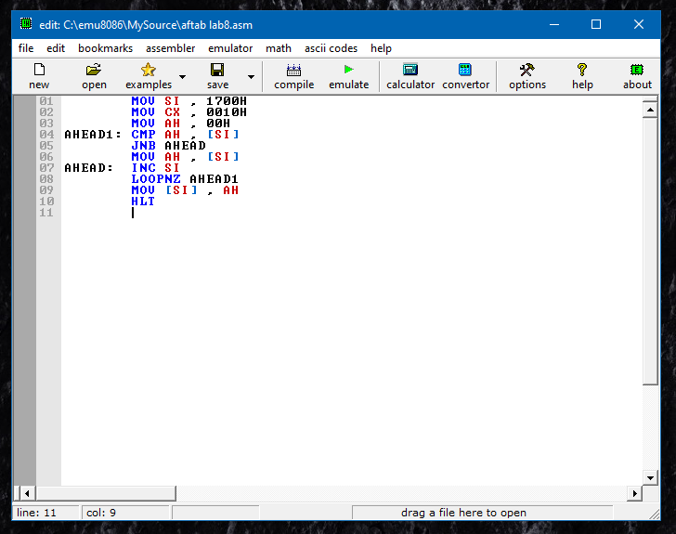

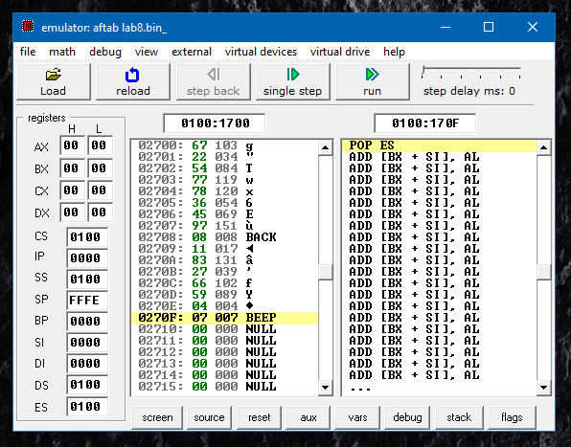

**Flow Chart :**

**No**

**Yes**

**No**

**Yes**

**Output :**

|  |  |  |  |  |  |  |  |  |  |  |  |  |  |  |  |
| --- | --- | --- | --- | --- | --- | --- | --- | --- | --- | --- | --- | --- | --- | --- | --- |
| **Input Values** | | | | | | | | | | | | | | | |
| **1700H** | **1701H** | **1702H** | **1703H** | **1704H** | **1705H** | **1706H** | **1707H** | **1708H** | **1709H** | **170AH** | **170BH** | **170CH** | **170DH** | **170EH** | **170FH** |
| **67** | **22** | **54** | **77** | **78** | **36** | **45** | **97** | **08** | **11** | **83** | **27** | **66** | **59** | **04** | **07** |

|  |  |
| --- | --- |
| **Output Value (Result)** | |
| **1710H** | **97** |

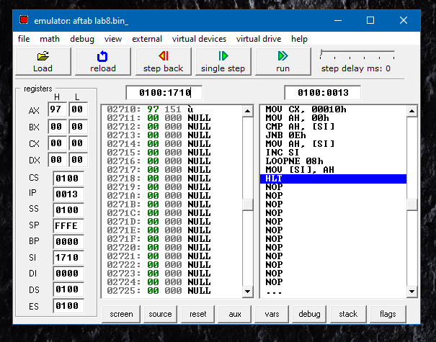

**Result :**

**Yes**

Program to Find the Greatest Number in a String of Numbers was implemented successfully.